I came across article (<https://www.coindesk.com/using-google-trends-estimate-bitcoins-user-growth/>) which talks about google trends estimate bitcoins trend. I was surprised to see that google trends can act as a source for viewing the changing trends in bitcoin prices.

As per this article, Google trends is a great way to track the growth of bitcoin users. This is only my understanding and does not confirm anything.

I understand that google trends is a source to understand the current trend of users who are searching for bitcoin prices. So I wanted to cross check the prices <https://coinmarketcap.com>

I started with searching with the term “Bitcoin(BTC)” in the google trends search term option for 12 months. Below is the snapshot. The below google trends chart shows search volume of how many people are bitcoin currency on google. If you are a active bitcoin user, it's likely you'll be checking the prices regularly. If you look for the month of May 2017, May 25th  price, there is a heavy search volume for bitcoin.

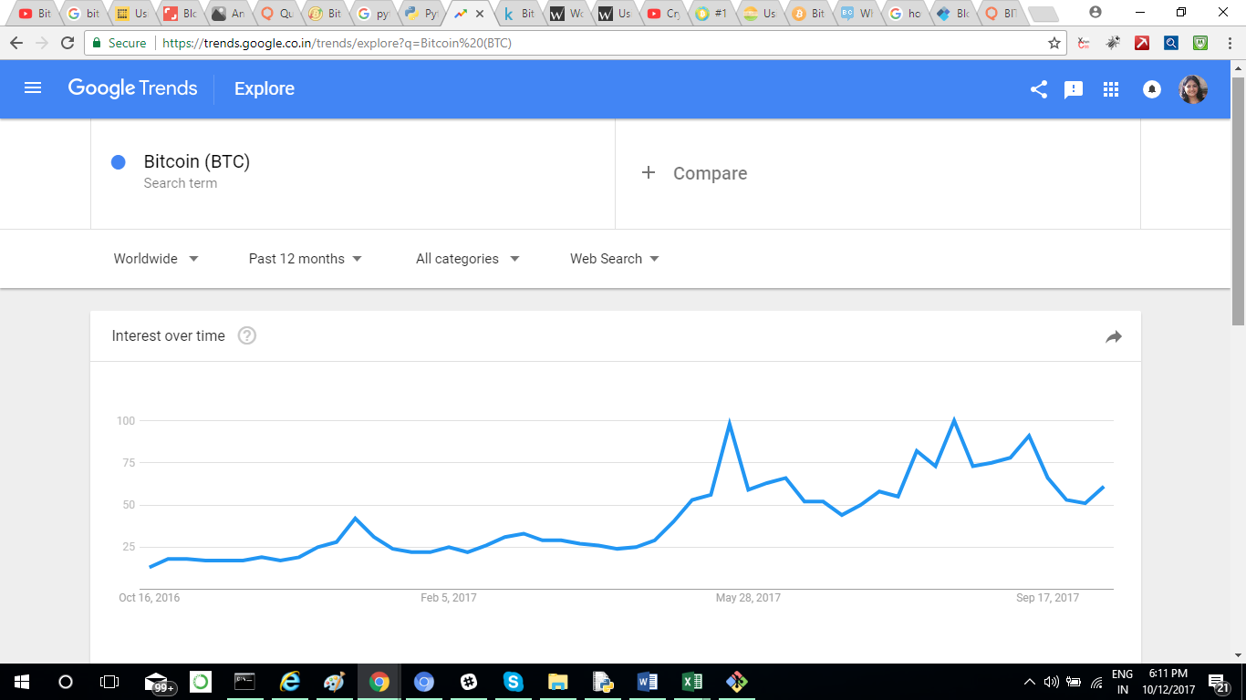

If you now go and search for Bitcoin for the given days in the link to <https://coinmarketcap.com>

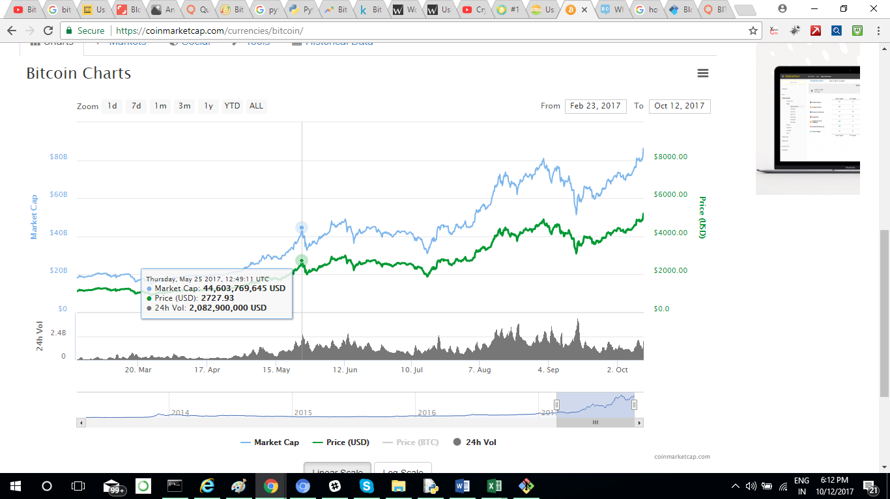

If you look at the above image, for the data 2017, May 25th  price of bitcoin is 2727.93 USD. If you check the google trends search value for the same date, you can see that search volume is high during that time.

My understanding is since more people are searching for the bitcoin prices, the market value is increased. Though we cannot conclude anything from this use case but google trends can be treated as a source for understanding bitcoin trend. There is also a study that the search 'BTC USD' serves as a proxy for the engagement of active bitcoin users as they check the daily price. The google chart above denotes the exponential growth of active users and the same trend is in the bitcoin price.

Need to explore more on this.